Name : HEMANTH VARDHAN
Reg. No : 11604088
Section : K1616
Roll No. : B28
E-mail : tallapaneni.hemanth@gmail.com
Github ID :

Question No. 1
Q 9:Design a scheduler that uses a preemptive priority scheduling algorithm based on dynamically changing priority. Larger number for priority indicates higher priority. Assume that the following processes with arrival time and service time wants to execute. When the process starts execution (i.e. CPU assigned), priority for that process changes at the rate of m=1.When the process waits for CPU in the ready queue (but not yet started execution), its priority changes at a rate n=2. All the processes are initially assigned priority value of 0 when they enter ready queue for the first time . The time slice for each process is q = 1. When two processes want to join ready queue simultaneously, the process which has not executed recently is given priority. Calculate the average waiting time for each process. The program must be generic i.e. number of processes, their burst time and arrival time must be entered by user.
Q 10:Design a scheduler with multilevel queue having two queues which will schedule the processes on the basis of pre-emptive shortest remaining processing time first algorithm (SROT) followed by a scheduling in which each process will get 2 units of time to execute. Also note that queue 1 has higher priority than queue 2.Calculate the average turnaround time and average waiting time for each process. The input for number of processes and their arrival time, burst time should be given by the user.
Question No. 2
Algorithm for Problem – 9:
- Take input from the user about the arrival and burst time of 4 processes.
- Consider size of arrival time,burst time,completion time of any array size.
- Initialize the status of all the process to zero.
- The time slice should be 1.
- Compute the completion time for each process by using the total time variable.
- Maintain a queue or an array to store all the processes which have executed.
- Now, calculate the average total time, average wait time accordingly.

Algorithm for Problem – 10:
- Take input from the user about the number of process and their arrival time,burst time.
- Create two queues for scheduling the processes.
- Initialize the status of all the process to zero.
- Start processing the queue using shortest job first and round robin method.
- Time quantum must be 2 seconds.
- Calculate the average turnaround time ,avg waiting time.

Question No. 3
Problem No. 9
Complexity: n*n
Problem No. 10
Complexity: nlog(n)

Question No. 4
Problem No 9
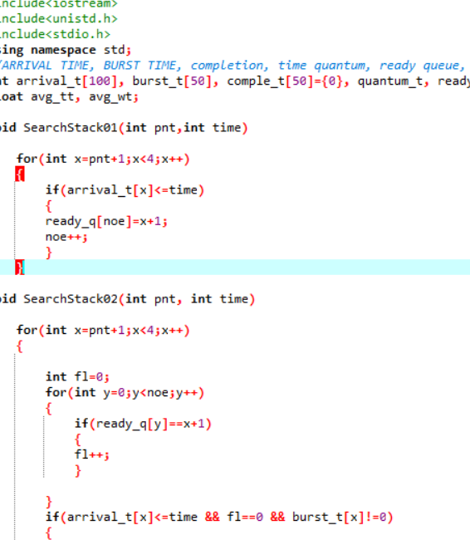

Problem No 10
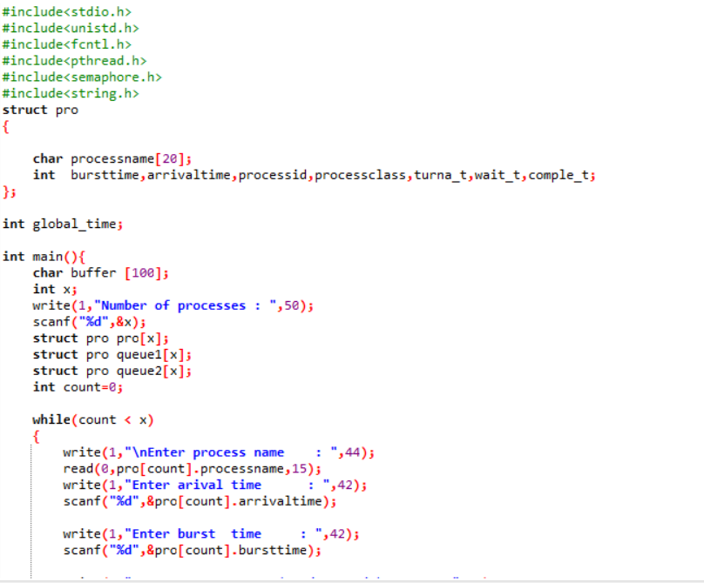

Question No. 5
The additional algorithm used in the both the problems is to sort the objects of the structures according to the arrival time and burst time.
It is used to implement the shortest job first or the First com first serve algorithm

Question No. 6
The boundary conditions of the algorithm used in both the question is the number of input cases. Which in this case is given 20 input-size.

Question No. 7
Test – Cases
Problem No. 9
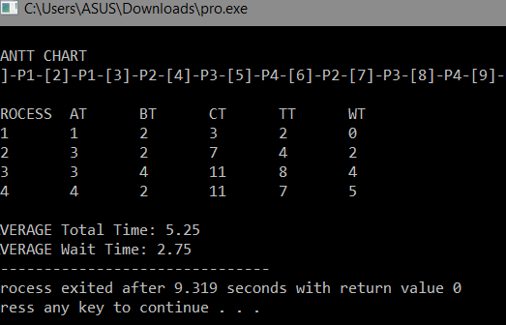

Problem No. 10
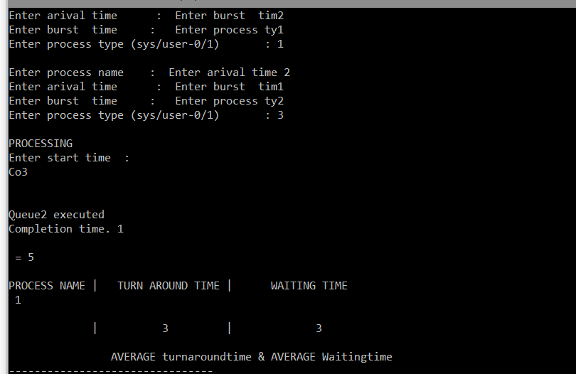

Question No. 8
No, I’ve uploaded the project but did not create 5 repositories of it previously.

